**SOLUTION IMPLEMENTATION CHANGE**

1. **Requirement change development.**

**Attachment:**

“Regarding the technical implementation following is suggested:

1.      Have all Order Cubes (OI, TO and OB) in two versions

a.      First Version with Pre-calculated values ONLY, so always pre-calc., even if post-calc. is available

b.      Second Version with “most up to date” values, so take post-calc. if available and pre-calc. if there is no post-calc

i.     These Cubes should contain an additional Entity “Calculation Status” indicating whether the Order is “Pre-calc.” or “Post-calc.” (naming is just a suggestion)

So, establish a new Entity “Calculation Status” as well as building up all order data cubes in twice.”

1. **Clarification Requirement Change Development**
2. **Evaluation of Current System**
   1. Board
   2. DWH
      1. Context Diagram LoadToFact

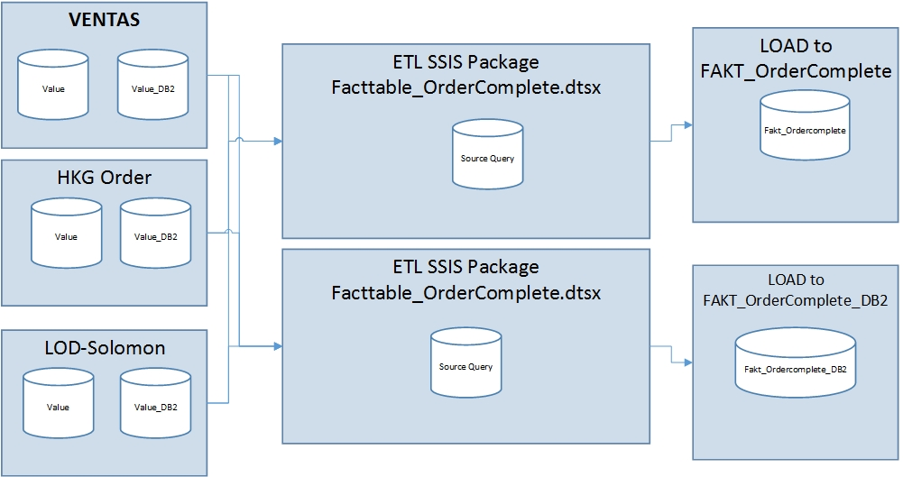

Figure 1: Diagram data flow Load to Fakt_ordercomplete

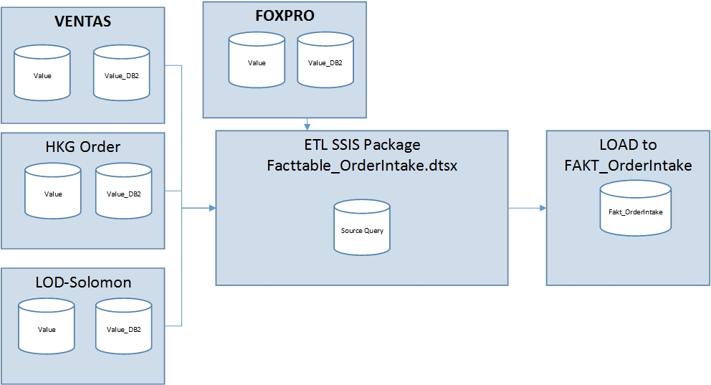

Figure 2: diagram data flow Fakt_OrderIntake

* + 1. Structure Table and View for OrderComplete
* Table FAKT_OrderComplete

[ordercomplete_value] Field is stored the final value of Order

[ordercomplete_value_currency] Field is stored the final value_currency of Order

[ordercomplete_db2] Field

[ordercomplete_db2_currency] Field

* Current Mapping:
* **Ventas:Ventas_Ordercomplete_trade_value**

Preis_ges_dm🡪ordercomplete_value

Preis_ges_wr🡪ordercomplete_value_currency

Ignore🡪 ordercomplete_db2

Ignore🡪 ordercomplete_db2_currency

* **Ventas:Ventas_Ordercomplete_commision_Value**

Preis_ges_dm🡪ordercomplete_value

Preis_ges_wr🡪ordercomplete_value_currency

Ignore🡪 ordercomplete_db2

Ignore🡪 ordercomplete_db2_currency

* **LOD-Solomon: Non HKG orders and FOXPRO orders before 2013 - Fact Order Complete**

ordercomplete_value 🡪ordercomplete_value

ordercomplete_value_currency 🡪ordercomplete_value_currency

Ignore🡪 ordercomplete_db2

Ignore🡪 ordercomplete_db2_currency

* **LOD-Solomon: HKG orders and FOXPRO orders since 2013 - Fact Order Complete**

ordercomplete_value 🡪ordercomplete_value

ordercomplete_value_currency 🡪ordercomplete_value_currency

Ignore🡪 ordercomplete_db2

Ignore🡪 ordercomplete_db2_currency

* **Local-Orders: Local Orders_OrderComplete_Value**

Wert_Wrg 🡪ordercomplete_value

Ignore 🡪ordercomplete_value_currency

Ignore🡪 ordercomplete_db2

Ignore🡪 ordercomplete_db2_currency

* Table FAKT_OrderComplete_DB2

[ordercomplete_value] Field

[ordercomplete_value_currency] Field

[ordercomplete_db2] Field is stored the final value_db2 of order

[ordercomplete_db3] Field is stored the final value_db3 of order

[ordercomplete_db2_currency] Field is store the final value_db2_currency of order

* Mapping :
* **Ventas:Ventas_Ordercomplete_trade_value**

Ignore 🡪ordercomplete_value

Ignore 🡪ordercomplete_value_currency

DB2🡪 ordercomplete_db2

Ignore🡪 ordercomplete_db2_currency

Ignore🡪 ordercomplete_db3

* **Ventas:Ventas_Ordercomplete_commision_Value**

Ignore 🡪ordercomplete_value

Ignore 🡪ordercomplete_value_currency

DB2🡪 ordercomplete_db2

Ignore🡪 ordercomplete_db2_currency

Ignore🡪 ordercomplete_db3

* **LOD-solomon: Non HKG orders and FOXPRO orders before 2013 - Fact Order Complete**

Ignore 🡪ordercomplete_value

Ignore 🡪ordercomplete_value_currency

ordercomplete_db2🡪 ordercomplete_db2

Ignore🡪 ordercomplete_db2_currency

ordercomplete_db3🡪 ordercomplete_db3

* **LOD-solomon: HKG orders and FOXPRO orders since 2013 - Fact Order Complete**

Ignore 🡪ordercomplete_value

Ignore 🡪ordercomplete_value_currency

ordercomplete_db2🡪 ordercomplete_db2

Ignore🡪 ordercomplete_db2_currency

ordercomplete_db3🡪 ordercomplete_db3

* **Local-Orders: Local Orders_OrderComplete_Value**

Ignore 🡪ordercomplete_value

Ignore 🡪ordercomplete_value_currency

DB2🡪 ordercomplete_db2

Ignore🡪 ordercomplete_db2_currency

Ignore 🡪 ordercomplete_db2

1. **Solution Development Change for Ordercomplete**
   1. Board
   2. DWH
      1. Staging Structure database.

Add new five columns into FAKT_OrderComplete and FAKT_OrderComplete_DB2. Don’t change or replace any current columns to ensure that System will be run fine and avoid largely impacts cannot handle in a short time

* FAKT_OrderComplete

[PreCal_Value] [money] NULL,

[PreCal_Value_Currency] [money] NULL,

[PostCal_Value] [money] NULL,

[PostCal_Value_Currency] [money] NULL,

[Calculation_Status] [bit] NULL

* FAKT_OrderComplete_DB2

[PreCal_Value_DB2] [money] NULL,

[PreCal_Value_DB3] [money] NULL,

[PostCal_Value_DB2] [money] NULL,

[PostCal_Value_DB3] [money] NULL,

[Calculation_Status] [bit] NULL

These views will be changed structure. In Fact, add new five columns in list of below views

* [dbo].[vTMP_VENTAS_OrderComplete_Comm_DB2pos]

In the first statement, we agreed that the Value DB2 is post-calculation. Just copying logic DB2 and then save as new columns Post_Value_DB2. Although this view has not contained PreCal_Value_DB2, PreCal_Value_DB3, PostCal_Value_DB3,[Calculation_Status] before, we add these columns in this view

'0' AS PreCal_Value_DB2,

'0' AS PreCal_Value_DB3,

SUM(c.b_betrag) * CASE

WHEN b.preis_ges_dm_ges = 0

THEN a.preis_ges_dm / (anz_pos * 1.0)

ELSE a.preis_ges_dm / b.preis_ges_dm_ges * 100

END / 100 AS PostCal_Value_DB2,

'0' AS PostCal_Value_DB3,

'1' AS [Calculation_Status],

In the second statement, We agreed that Value DB2 is Pre-calculation. Just copying logic DB2 and then save as new column PreCal_Value_DB2. Although this view has not contained PostCal_Value_DB2, PostCal_Value_DB3, PreCal_Value_DB3,[Calculation_Status] before, we add these columns in this view

b.db2 AS PreCal_Value_DB2,

'0' AS PreCal_Value_DB3,

'0' AS PostCal_Value_DB2,

'0' AS PostCal_Value_DB3,

'0' AS [Calculation_Status],

* [dbo].[vTMP_VENTAS_OrderComplete_Comm_Value]

We agreed that with commission Order only have pre-calculation.Just copying bbo.LZ_VENTAS_akpos.preis_ges_wr, dbo.LZ_VENTAS_akpos.preis_ges_dm and them save as PreCal_Value_Currency and PreCal_Value . Concurrently, add new columns PostCal_Value, PostCal_Value_Currency, [Calculation_Status]

* vTMP_VENTAS_OrderComplete_Trade_DB2pos

In the first statement , we agreed that the Value DB2 is post-calculation. Just copying logic DB2 and then save as new columns Post_Value_DB2 . Although this view has not contained PreCal_Value_DB2, PreCal_Value_DB3, PostCal_Value_DB3,[Calculation_Status] before, we add these columns in this view

'0' AS PreCal_Value_DB2,

'0' AS PreCal_Value_DB3,

SUM(c.b_betrag) * CASE

WHEN b.preis_ges_dm_ges = 0

THEN a.preis_ges_dm / (anz_pos * 1.0)

ELSE a.preis_ges_dm / b.preis_ges_dm_ges * 100

END / 100 AS PostCal_Value_DB2,

'0' AS PostCal_Value_DB3,

'1' AS [Calculation_Status],

In the second statement, We agreed that Value DB2 is Pre-calculation. Just copying logic DB2 and then save as new column PreCal_Value_DB2. Although this view has not contained PostCal_Value_DB2, PostCal_Value_DB3, PreCal_Value_DB3,[Calculation_Status] before, we add these columns in this view

b.db2 AS PreCal_Value_DB2,

'0' AS PreCal_Value_DB3,

'0' AS PostCal_Value_DB2,

'0' AS PostCal_Value_DB3,

'0' AS [Calculation_Status],

* vTMP_VENTAS_OrderComplete_Trade_Value

Don’t change logic calculation of two fields because two fields is used in another views so that we add new logic calculation to create new fields(PreCal_Value ,PreCal_Value_Currency , PostCal_Value_Currency , PostCal_Value, Calculation_Status ) which rely on two fields existing (preis_ges_wr, preis_ges_dm)

a.preis_ges_wr AS PreCal_Value_Currency,

a.preis_ges_dm AS PreCal_Value,

CASE

WHEN a.abgerechnet_dat IS NOT NULL

THEN b.preis_ges_wr

ELSE 0

END AS PostCal_Value_Currency,

CASE

WHEN a.abgerechnet_dat IS NOT NULL

THEN b.preis_ges_dm

ELSE 0

END AS PostCal_Value,

CASE

WHEN a.abgerechnet_dat IS NOT NULL

THEN 1

ELSE 0

END AS [Calculation_Status],

-- if abgrechnet_dat is null then order intake value else invoice values

CASE

WHEN a.abgerechnet_dat IS NULL

THEN a.preis_ges_wr

ELSE b.preis_ges_wr

END AS preis_ges_wr,

CASE

WHEN a.abgerechnet_dat IS NULL

THEN a.preis_ges_dm

ELSE b.preis_ges_dm

END AS preis_ges_dm,

* + 1. SSIS Package ETL

Change source query script to load data into FAKT_OrderComplete and edit mapping from source to destination of FAKT_OrderComplete_DB2

Source query FAKT_Complete

PreCal_Value 🡪 PreCal_Value

PreCal_Value_Currency 🡪 PreCal_Value_Currency

PostCal_Value 🡪 PostCal_Value

PostCal_Value_Currency 🡪 PostCal_Value_Currency

Calculation_Status 🡪 Calculation_Status

Change source query script to load data into FAKT_OrderComplete and edit mapping from source to destination of FAKT_OrderComplete_DB2

Source query FAKT_Complete _DB2

PreCal_Value_DB2, 🡪 PreCal_Value_DB2,

PreCal_Value_DB3 🡪 PreCal_Value_DB3

PostCal_Value_DB2 🡪 PostCal_Value_DB2

PostCal_Value_DB3 🡪 PostCal_Value_DB3

Calculation_Status 🡪 Calculation_Status

1. Implementation for Ordercomplete
   1. DWH
      1. Staging Structure Database

* Change Structure FAKT_OrderComplete table by adding new five columns

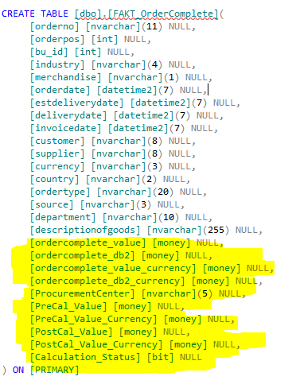 Old structure New structure

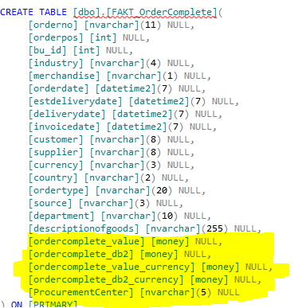

* Change structure FAKT_OrderComplete_DB2 table by adding new five columns

Old Structure New Structure

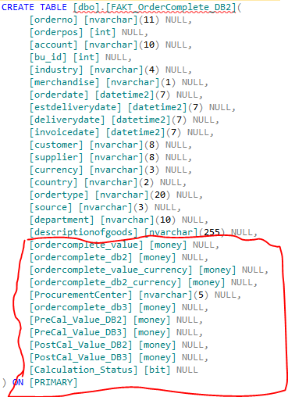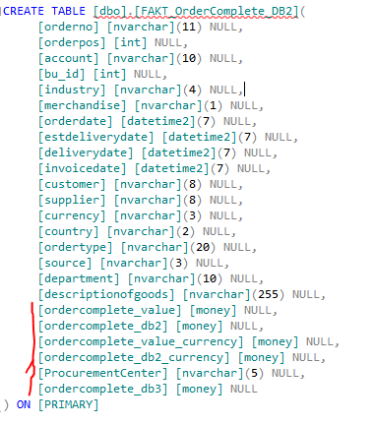

* Change Structure view [vTMP_VENTAS_OrderComplete_Comm_DB2pos]

Old Structure New Structure

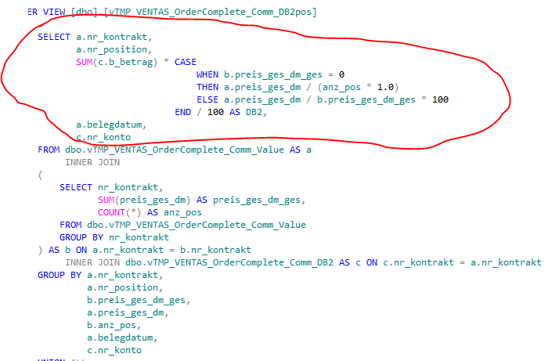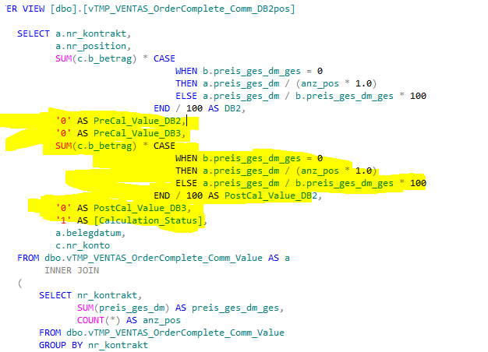

* Change structure view [vTMP_VENTAS_OrderComplete_Comm_Value]

Old Structure New Structure

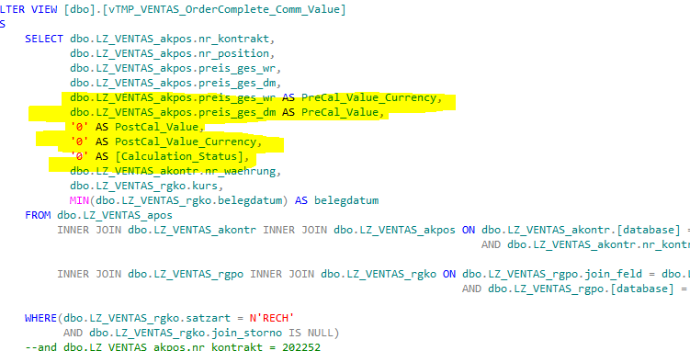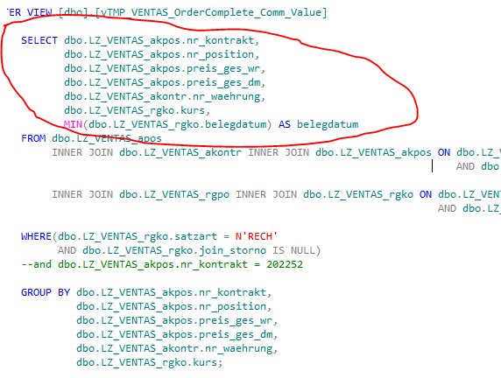

* Change structure view [vTMP_VENTAS_OrderComplete_Trade_DB2pos]

Old Structure New Structure

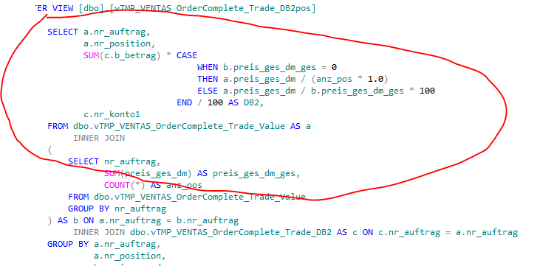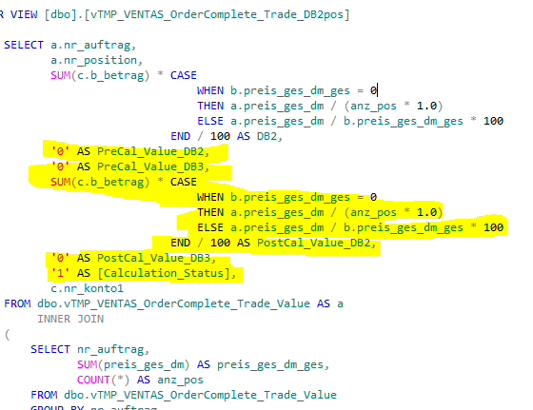

* Change Structure View [vTMP_VENTAS_OrderComplete_Trade_Value]

Old Structure New Structure

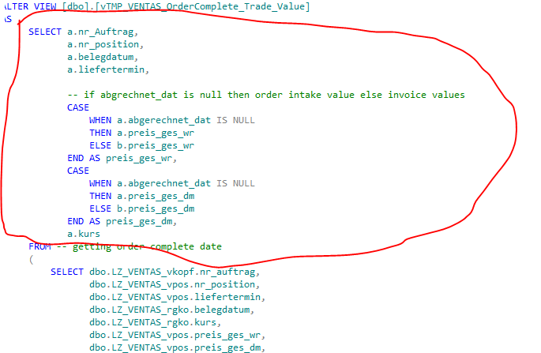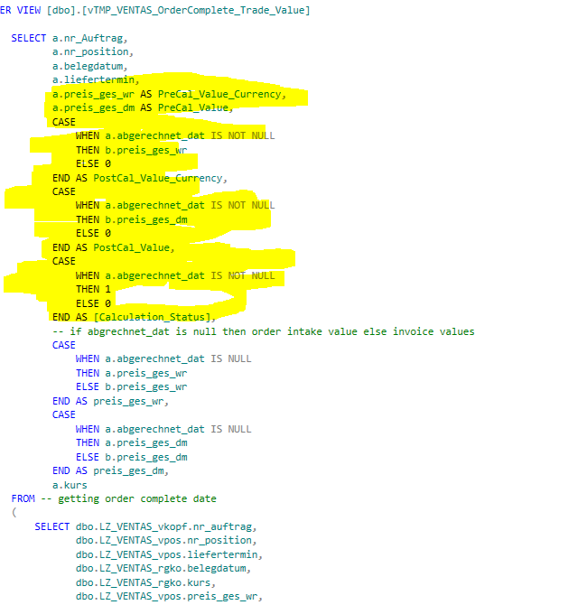

5.1.2. SSIS Package

- Change Source Query Load to Fact from Ventas, Local HKG Orders, LOD-Solomon to FAKT_OrderComplete table and FAKT_OrderComplete_DB2

Old Script Source Query New Script Source Query

 

* 1. Board

1. Solution and Implementation change for OrderIntake

**6.1. SSIS package**

Control data flow

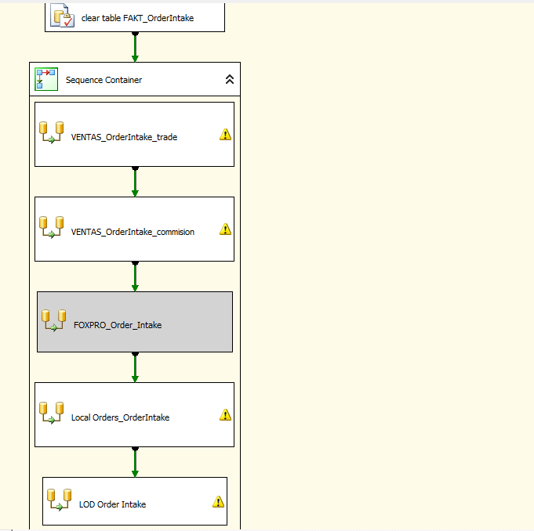

**6.1.1. Ventas source Trade**

**Original source query load data**

SELECT a.nr_auftrag,

a.erfasst,

a.abgerechnet_dat,

a.betreff,

a.nr_kunde,

a.nr_liefnt,

a.bez,

a.nr_gart AS industry,

a.cty, a.department,

a.nr_position_vpos,

a.liefertermin,

RTRIM(a.Merchandise) AS Merchandise,

a.preis_ges_dm,

a.preis_ges_wr,

b.DB2,

a.bu_id,

a.currency,

a.Backlogrelevant,

a.office_reference

FROM dbo.vTMP_VENTAS_OrderIntake_Trade_02_BU AS a INNER JOIN

dbo.vTMP_VENTAS_OrderIntake_Trade_03_DB2pos AS b ON a.nr_auftrag = b.nr_auftrag

AND a.nr_position_vpos = b.nr_position_vpos

WHERE (a.erfasst >= '2008-01-01')

**Mapping:**

preis_ges_dm 🡪 orderintake_value

preis_ges_wr 🡪 orderintake_value_currency

DB2 🡪 orderintake_db2

**Current Logic data :get all value Pre of all orderno**

**Change logic to get post value of all order had post value.**

/*VENTAS_OrderIntake_trade*/

WITH temp1(nr_auftrag,erfasst,abgerechnet_dat,betreff,nr_kunde,nr_liefnt,bez,industry,cty,department,nr_position_vpos,liefertermin,Merchandise,preis_ges_dm,preis_ges_wr,DB2,bu_id,currency,Backlogrelevant,office_reference)

--temp1 table stores all data value Pre of All orderno. this is original source

AS

(SELECT a.nr_auftrag,

a.erfasst,

a.abgerechnet_dat,

a.betreff,

a.nr_kunde,

a.nr_liefnt,

a.bez,

a.nr_gart AS industry,

a.cty,

a.department,

a.nr_position_vpos,

a.liefertermin,

RTRIM(a.Merchandise) AS Merchandise,

a.preis_ges_dm,

a.preis_ges_wr,

b.DB2,

a.bu_id,

a.currency,

a.Backlogrelevant,

a.office_reference

FROM dbo.vTMP_VENTAS_OrderIntake_Trade_02_BU AS a

INNER JOIN dbo.vTMP_VENTAS_OrderIntake_Trade_03_DB2pos AS b ON a.nr_auftrag = b.nr_auftrag

AND a.nr_position_vpos = b.nr_position_vpos

WHERE(a.erfasst >= '2008-01-01')

),

--because temp1 table stores all data value Pre of All orderno. it contains Pre value of orders not yet complete and complete. we find Ordercompletes to get post Value. So that we create temp2 to include Pre value and Post value

temp2(nr_auftrag,erfasst,abgerechnet_dat,betreff,nr_kunde,nr_liefnt,bez,industry,cty,department,nr_position_vpos,liefertermin,Merchandise,preis_ges_dm,preis_ges_wr,DB2,bu_id,currency,Backlogrelevant,office_reference,Postcal_IntakeDB2

,Postcal_IntakeDB2_currency,PostCal_Value_DB3,Precal_IntakeDB2,Precal_IntakeDB2_Currency,Precal_IntakeDB3,Postcal_IntakeDB3,

Precal_IntakeValue_Currency,Precal_IntakeValue,Postcal_IntakeValue_Currency,Postcal_IntakeValue,Calculation_Status)

AS

(SELECT FAKT_OrderIntake.nr_auftrag,

FAKT_OrderIntake.erfasst,

FAKT_OrderIntake.abgerechnet_dat,

FAKT_OrderIntake.betreff,

FAKT_OrderIntake.nr_kunde,

FAKT_OrderIntake.nr_liefnt,

FAKT_OrderIntake.bez,

FAKT_OrderIntake.industry,

FAKT_OrderIntake.cty,

FAKT_OrderIntake.department,

FAKT_OrderIntake.nr_position_vpos,

FAKT_OrderIntake.liefertermin,

FAKT_OrderIntake.Merchandise,

FAKT_OrderIntake.preis_ges_dm,

FAKT_OrderIntake.preis_ges_wr,

FAKT_OrderIntake.DB2,

FAKT_OrderIntake.bu_id,

FAKT_OrderIntake.currency,

FAKT_OrderIntake.Backlogrelevant,

FAKT_OrderIntake.office_reference,

vTMP_VENTAS_OrderComplete_Trade_DB2pos.Postcal_IntakeDB2,

'0' AS Postcal_IntakeDB2_currency,

vTMP_VENTAS_OrderComplete_Trade_DB2pos.PostCal_Value_DB3,

vTMP_VENTAS_OrderComplete_Trade_DB2pos.Precal_IntakeDB2,

'0' AS Precal_IntakeDB2_Currency,

vTMP_VENTAS_OrderComplete_Trade_DB2pos.Precal_IntakeDB3,

'0' AS Postcal_IntakeDB3,

dbo.vTMP_VENTAS_OrderComplete_Trade_Value.PreCal_Value_Currency AS Precal_IntakeValue_Currency,

dbo.vTMP_VENTAS_OrderComplete_Trade_Value.PreCal_Value AS Precal_IntakeValue,

dbo.vTMP_VENTAS_OrderComplete_Trade_Value.PostCal_Value_Currency AS Postcal_IntakeValue_Currency,

dbo.vTMP_VENTAS_OrderComplete_Trade_Value.PostCal_Value AS Postcal_IntakeValue,

dbo.vTMP_VENTAS_OrderComplete_Trade_Value.[Calculation_Status] AS Calculation_Status

FROM temp1 AS FAKT_OrderIntake

--Get Post Value And Pre value of orderscomplete from vTMP_VENTAS_OrderComplete_Trade_Value

LEFT JOIN dbo.vTMP_VENTAS_OrderComplete_Trade_Value ON dbo.vTMP_VENTAS_OrderComplete_Trade_Value.nr_auftrag = FAKT_OrderIntake.nr_auftrag

AND dbo.vTMP_VENTAS_OrderComplete_Trade_Value.nr_position = FAKT_OrderIntake.nr_position_vpos

LEFT JOIN

--Get Post value DB2 and Pre Value DB2 of orderscomplete from vTMP_VENTAS_OrderComplete_Trade_DB2pos

(

SELECT dbo.vTMP_VENTAS_OrderComplete_Trade_DB2pos.nr_auftrag,

dbo.vTMP_VENTAS_OrderComplete_Trade_DB2pos.nr_position,

SUM(CASE

WHEN dbo.vTMP_VENTAS_OrderComplete_Trade_DB2pos.nr_konto1 = '3730'

AND dbo.vTMP_VENTAS_OrderComplete_Trade_DB2pos.[Calculation_Status] = 1

THEN dbo.vTMP_VENTAS_OrderComplete_Trade_DB2pos.PostCal_Value_DB2 / 2

ELSE dbo.vTMP_VENTAS_OrderComplete_Trade_DB2pos.PostCal_Value_DB2

END) AS Postcal_IntakeDB2,

SUM(CAST(dbo.vTMP_VENTAS_OrderComplete_Trade_DB2pos.PostCal_Value_DB3 AS INT)) AS PostCal_Value_DB3,

SUM(CASE

WHEN dbo.vTMP_VENTAS_OrderComplete_Trade_DB2pos.nr_konto1 = '3730'

AND dbo.vTMP_VENTAS_OrderComplete_Trade_DB2pos.[Calculation_Status] = 0

THEN dbo.vTMP_VENTAS_OrderComplete_Trade_DB2pos.PreCal_Value_DB2 / 2

ELSE dbo.vTMP_VENTAS_OrderComplete_Trade_DB2pos.PreCal_Value_DB2

END) AS Precal_IntakeDB2,

SUM(CAST(dbo.vTMP_VENTAS_OrderComplete_Trade_DB2pos.PreCal_Value_DB3 AS INT)) AS Precal_IntakeDB3

FROM dbo.vTMP_VENTAS_OrderComplete_Trade_DB2pos

GROUP BY dbo.vTMP_VENTAS_OrderComplete_Trade_DB2pos.nr_auftrag,

dbo.vTMP_VENTAS_OrderComplete_Trade_DB2pos.nr_position

) AS vTMP_VENTAS_OrderComplete_Trade_DB2pos ON vTMP_VENTAS_OrderComplete_Trade_DB2pos.nr_auftrag = FAKT_OrderIntake.nr_auftrag

AND vTMP_VENTAS_OrderComplete_Trade_DB2pos.nr_position = FAKT_OrderIntake.nr_position_vpos)

-- this is the process to solve null value. if null value then 0 from temp2

SELECT a.nr_auftrag,

a.erfasst,

a.abgerechnet_dat,

a.betreff,

a.nr_kunde,

a.nr_liefnt,

a.bez,

a.industry,

a.cty,

a.department,

a.nr_position_vpos,

a.liefertermin,

RTRIM(a.Merchandise) AS Merchandise,

a.preis_ges_dm,

a.preis_ges_wr,

a.DB2,

a.bu_id,

a.currency,

a.Backlogrelevant,

a.office_reference,

CASE

WHEN ISNULL(a.Precal_IntakeValue, 0) = 0

THEN a.preis_ges_dm

ELSE ISNULL(a.Precal_IntakeValue, 0)

END AS Precal_IntakeValue,

CASE

WHEN ISNULL(a.Precal_IntakeDB2, 0) = 0

THEN a.DB2

ELSE ISNULL(a.Precal_IntakeDB2, 0)

END AS Precal_IntakeDB2,

ISNULL(a.Precal_IntakeDB2_Currency, 0) AS Precal_IntakeDB2_Currency,

CASE

WHEN ISNULL(a.Precal_IntakeValue_Currency, 0) = 0

THEN a.preis_ges_wr

ELSE ISNULL(a.Precal_IntakeValue_Currency, 0)

END AS Precal_IntakeValue_Currency,

ISNULL(a.Postcal_IntakeValue, 0) AS Postcal_IntakeValue,

ISNULL(a.Postcal_IntakeValue_Currency, 0) AS Postcal_IntakeValue_Currency,

ISNULL(a.Postcal_IntakeDB2, 0) AS Postcal_IntakeDB2,

ISNULL(a.Postcal_IntakeDB2_currency, 0) AS Postcal_IntakeDB2_currency,

ISNULL(a.Precal_IntakeDB3, 0) AS Precal_IntakeDB3,

ISNULL(a.Postcal_IntakeDB3, 0) AS Postcal_IntakeDB3,

CASE

WHEN a.[Calculation_Status] IS NULL

THEN 0

ELSE a.[Calculation_Status]

END AS Calculation_Status

FROM temp2 AS a;

**New Mapping :**

Precal_IntakeValue 🡪Precal_IntakeValue,

Precal_IntakeDB2🡪Precal_IntakeDB2,

Precal_IntakeDB2_Currency 🡪Precal_IntakeDB2_Currency,

Precal_IntakeValue_Currency 🡪Precal_IntakeValue_Currency,

Postcal_IntakeValue 🡪Postcal_IntakeValue,

Postcal_IntakeValue_Currency 🡪Postcal_IntakeValue_Currency,

Postcal_IntakeDB2🡪Postcal_IntakeDB2,

Postcal_IntakeDB2_currency 🡪Postcal_IntakeDB2_currency,

Precal_IntakeDB3🡪Precal_IntakeDB3,

Postcal_IntakeDB3🡪Postcal_IntakeDB3,

[Calculation_Status]🡪[Calculation_Status]

### 6.1.2. Ventas source commission

**Original Source Query Load**

SELECT b.nr_position,

a.nr_kontrakt,

a.abgerechnet_dat,

a.nr_liefnt,

a.nr_kunde,

a.nr_gart AS industry,

a.erfasst,

a.seriell,

a.liefertermin,

a.bez,

RTRIM(a.Merchandise) AS Merchandise,

a.nr_adress_k,

a.cty,

a.department,

a.preis_ges_dm,

a.preis_ges_wr,

b.DB2,

a.bu_id,

a.currency,

a.Backlogrelevant,

a.office_reference

FROM dbo.vTMP_VENTAS_OrderIntake_Comm_02_BU AS a

INNER JOIN dbo.vTMP_VENTAS_OrderIntake_Comm_03_DB2pos AS b ON a.nr_kontrakt = b.nr_kontrakt

AND a.nr_position = b.nr_position

WHERE(a.erfasst >= '2008-01-01');

**Mapping:**

preis_ges_dm 🡪 orderintake_value

preis_ges_wr 🡪 orderintake_value_currency

DB2 🡪 orderintake_db2

**Current Logic data: get all value Pre of all orderno**

**Change logic to get post value of all order had post value.**

/*VENTAS_OrderIntake_commision*/

GO

IF OBJECT_ID('dbo.vTMPSourceLoadOderIntakeDB2_Post', 'V') IS NOT NULL

DROP VIEW [dbo].[vTMPSourceLoadOderIntakeDB2_Post]

GO

--Because with Ventas Commission order doesn't not have post value for ordercomplete_value, only pre value for orders. we can get post value DB2 and is not with Post Value

--vTMPSourceLoadOderIntakeDB2_Post will contain Post Value DB2 of ordercompletes

CREATE VIEW [dbo].[vTMPSourceLoadOderIntakeDB2_Post]

AS

SELECT dbo.vTMP_VENTAS_OrderComplete_Comm_DB2pos.nr_kontrakt,

dbo.vTMP_VENTAS_OrderComplete_Comm_DB2pos.nr_position,

dbo.vTMP_VENTAS_OrderComplete_Comm_DB2pos.Calculation_Status,

SUM(CASE

WHEN dbo.vTMP_VENTAS_OrderComplete_Comm_DB2pos.nr_konto = '3730'

AND dbo.vTMP_VENTAS_OrderComplete_Comm_DB2pos.[Calculation_Status] = 0

THEN dbo.vTMP_VENTAS_OrderComplete_Comm_DB2pos.PreCal_Value_DB2 / 2

ELSE dbo.vTMP_VENTAS_OrderComplete_Comm_DB2pos.PreCal_Value_DB2

END) AS Precal_IntakeDB2,

SUM(CAST(dbo.vTMP_VENTAS_OrderComplete_Comm_DB2pos.PreCal_Value_DB3 AS INT)) AS Precal_IntakeDB3,

SUM(CASE

WHEN dbo.vTMP_VENTAS_OrderComplete_Comm_DB2pos.nr_konto = '3730'

AND dbo.vTMP_VENTAS_OrderComplete_Comm_DB2pos.[Calculation_Status] = 1

THEN dbo.vTMP_VENTAS_OrderComplete_Comm_DB2pos.PostCal_Value_DB2 / 2

ELSE dbo.vTMP_VENTAS_OrderComplete_Comm_DB2pos.PostCal_Value_DB2

END) AS Postcal_IntakeDB2,

SUM(CAST(dbo.vTMP_VENTAS_OrderComplete_Comm_DB2pos.PostCal_Value_DB3 AS INT)) AS Postcal_IntakeDB3

FROM dbo.vTMP_VENTAS_OrderComplete_Comm_DB2pos

GROUP BY dbo.vTMP_VENTAS_OrderComplete_Comm_DB2pos.nr_kontrakt,

dbo.vTMP_VENTAS_OrderComplete_Comm_DB2pos.nr_position,

dbo.vTMP_VENTAS_OrderComplete_Comm_DB2pos.Calculation_Status

GO

GO

IF OBJECT_ID('dbo.vTMPSourceLoadOderIntake', 'V') IS NOT NULL

DROP VIEW [dbo].[vTMPSourceLoadOderIntake]

GO

--vTMPSourceLoadOderIntake is Original source, get all Pre value, Pre value DB2 of all orders

CREATE VIEW [dbo].[vTMPSourceLoadOderIntake]

AS

SELECT b.nr_position,

a.nr_kontrakt,

a.abgerechnet_dat,

a.nr_liefnt,

a.nr_kunde,

a.nr_gart AS industry,

a.erfasst,

a.seriell,

a.liefertermin,

a.bez,

RTRIM(a.Merchandise) AS Merchandise,

a.nr_adress_k,

a.cty,

a.department,

a.preis_ges_dm,

a.preis_ges_wr,

b.DB2,

a.bu_id,

a.currency,

a.Backlogrelevant,

a.office_reference

FROM dbo.vTMP_VENTAS_OrderIntake_Comm_02_BU AS a

INNER JOIN dbo.vTMP_VENTAS_OrderIntake_Comm_03_DB2pos AS b ON a.nr_kontrakt = b.nr_kontrakt

AND a.nr_position = b.nr_position

WHERE(a.erfasst >= '2008-01-01')

GO

-- Because Performamce Problem, we create two temp table (TMPLoadVentas_Comm_OrderIntake,TMPLoadVentas_Comm_OrderIntakeDB2_Post) to store data temporarily from vTMPSourceLoadOderIntake and vTMPSourceLoadOderIntakeDB2_Post

IF OBJECT_ID(N'dbo.TMPLoadVentas_Comm_OrderIntake', N'U') IS NOT NULL

DROP TABLE dbo.TMPLoadVentas_Comm_OrderIntake

CREATE TABLE [dbo].[TMPLoadVentas_Comm_OrderIntake](

nr_position [int] NOT NULL,

nr_kontrakt [nvarchar](11) NULL,

abgerechnet_dat [datetime2](7) null,

nr_liefnt [nvarchar](8) NULL,

nr_kunde [nvarchar](8) NULL,

industry [nvarchar](4) NULL,

erfasst [datetime2](7) NULL,

seriell int null,

liefertermin [datetime2](7) NULL,

bez [nvarchar](255) NULL,

Merchandise [nvarchar](1) NULL,

nr_adress_k [nvarchar](4) null,

cty [nvarchar](2) NULL,

department [nvarchar](10) NULL,

preis_ges_dm [money] NULL,

preis_ges_wr [money] NULL,

DB2 [money] NULL,

bu_id [nvarchar](3) NULL,

currency [nvarchar](3) NULL,

Backlogrelevant [varchar](1) NULL,

office_reference [nvarchar](30) NULL

) ON [PRIMARY]

IF OBJECT_ID(N'dbo.TMPLoadVentas_Comm_OrderIntakeDB2_Post', N'U') IS NOT NULL

DROP TABLE dbo.TMPLoadVentas_Comm_OrderIntakeDB2_Post

CREATE TABLE dbo.TMPLoadVentas_Comm_OrderIntakeDB2_Post

( nr_kontrakt [nvarchar](11) NULL,

nr_position [int] NOT NULL,

[Calculation_Status] [bit] NULL,

[Precal_IntakeDB2] [money] NULL,

[Precal_IntakeDB3] [money] NULL,

[Postcal_IntakeDB2] [money] NULL,

[Postcal_IntakeDB3] [money] NULL,

)ON [PRIMARY]

INSERT INTO dbo.TMPLoadVentas_Comm_OrderIntake

SELECT *

FROM vTMPSourceLoadOderIntake

INSERT INTO dbo.TMPLoadVentas_Comm_OrderIntakeDB2_Post

SELECT * from vTMPSourceLoadOderIntakeDB2_Post

GO

-- Query load data

--Temp is cte table to contain all value pre value , post value , pre value DB2, Post Value DB2, Pre value DB3, Post Value DB3

WITH temp(nr_position,

nr_kontrakt,

abgerechnet_dat,

nr_liefnt,

nr_kunde,

industry,

erfasst,

seriell,

liefertermin,

bez,

Merchandise,

nr_adress_k,

cty,

department,

preis_ges_dm,

preis_ges_wr,

DB2,

bu_id,

currency,

Backlogrelevant,

office_reference,

Precal_IntakeDB2,

Precal_IntakeDB2_Currency,

Precal_IntakeValue_Currency,

Precal_IntakeValue,

Precal_IntakeDB3,

Postcal_IntakeDB2,

Postcal_IntakeDB2_currency,

Postcal_IntakeValue_Currency,

Postcal_IntakeValue,

Postcal_IntakeDB3,

Calculation_Status)

AS

(SELECT FAKT_OrderIntake.nr_position,

FAKT_OrderIntake.nr_kontrakt,

FAKT_OrderIntake.abgerechnet_dat,

FAKT_OrderIntake.nr_liefnt,

FAKT_OrderIntake.nr_kunde,

FAKT_OrderIntake.industry,

FAKT_OrderIntake.erfasst,

FAKT_OrderIntake.seriell,

FAKT_OrderIntake.liefertermin,

FAKT_OrderIntake.bez,

FAKT_OrderIntake.Merchandise,

FAKT_OrderIntake.nr_adress_k,

FAKT_OrderIntake.cty,

FAKT_OrderIntake.department,

FAKT_OrderIntake.preis_ges_dm,

FAKT_OrderIntake.preis_ges_wr,

FAKT_OrderIntake.DB2,

FAKT_OrderIntake.bu_id,

FAKT_OrderIntake.currency,

FAKT_OrderIntake.Backlogrelevant,

FAKT_OrderIntake.office_reference,

vTMP_VENTAS_OrderComplete_Comm_DB2pos.Precal_IntakeDB2,

'0' AS Precal_IntakeDB2_Currency,

dbo.vTMP_VENTAS_OrderComplete_Comm_Value.PreCal_Value_Currency AS Precal_IntakeValue_Currency,

dbo.vTMP_VENTAS_OrderComplete_Comm_Value.PreCal_Value AS Precal_IntakeValue,

vTMP_VENTAS_OrderComplete_Comm_DB2pos.Precal_IntakeDB3,

vTMP_VENTAS_OrderComplete_Comm_DB2pos.Postcal_IntakeDB2,

'0' AS Postcal_IntakeDB2_currency,

dbo.vTMP_VENTAS_OrderComplete_Comm_Value.PostCal_Value_Currency AS Postcal_IntakeValue_Currency,

dbo.vTMP_VENTAS_OrderComplete_Comm_Value.PostCal_Value AS Postcal_IntakeValue,

vTMP_VENTAS_OrderComplete_Comm_DB2pos.Postcal_IntakeDB3,

vTMP_VENTAS_OrderComplete_Comm_DB2pos.Calculation_Status

FROM dbo.TMPLoadVentas_Comm_OrderIntake AS FAKT_OrderIntake

LEFT JOIN dbo.vTMP_VENTAS_OrderComplete_Comm_Value ON dbo.vTMP_VENTAS_OrderComplete_Comm_Value.nr_position = FAKT_OrderIntake.nr_position

AND dbo.vTMP_VENTAS_OrderComplete_Comm_Value.nr_kontrakt = FAKT_OrderIntake.nr_kontrakt

LEFT JOIN dbo.TMPLoadVentas_Comm_OrderIntakeDB2_Post vTMP_VENTAS_OrderComplete_Comm_DB2pos ON vTMP_VENTAS_OrderComplete_Comm_DB2pos.nr_kontrakt = FAKT_OrderIntake.nr_kontrakt

AND vTMP_VENTAS_OrderComplete_Comm_DB2pos.nr_position = FAKT_OrderIntake.nr_position)

--- this is the process to solve null value from temp data

SELECT a.nr_position,

a.nr_kontrakt,

a.abgerechnet_dat,

a.nr_liefnt,

a.nr_kunde,

a.industry,

a.erfasst,

a.seriell,

a.liefertermin,

a.bez,

RTRIM(a.Merchandise) AS Merchandise,

a.nr_adress_k,

a.cty,

a.department,

a.preis_ges_dm,

a.preis_ges_wr,

a.DB2,

a.bu_id,

a.currency,

a.Backlogrelevant,

a.office_reference,

CASE

WHEN ISNULL(a.Precal_IntakeValue, 0) = 0

THEN a.preis_ges_dm

ELSE ISNULL(a.Precal_IntakeValue, 0)

END AS Precal_IntakeValue,

CASE

WHEN ISNULL(a.Precal_IntakeDB2, 0) = 0

THEN a.DB2

ELSE ISNULL(a.Precal_IntakeDB2, 0)

END AS Precal_IntakeDB2,

ISNULL(a.Precal_IntakeDB2_Currency, 0) AS Precal_IntakeDB2_Currency,

CASE

WHEN ISNULL(a.Precal_IntakeValue_Currency, 0) = 0

THEN a.preis_ges_wr

ELSE ISNULL(a.Precal_IntakeValue_Currency, 0)

END AS Precal_IntakeValue_Currency,

ISNULL(a.Postcal_IntakeValue, 0) AS Postcal_IntakeValue,

ISNULL(a.Postcal_IntakeValue_Currency, 0) AS Postcal_IntakeValue_Currency,

ISNULL(a.Postcal_IntakeDB2, 0) AS Postcal_IntakeDB2,

ISNULL(a.Postcal_IntakeDB2_currency, 0) AS Postcal_IntakeDB2_currency,

ISNULL(a.Precal_IntakeDB3, 0) AS Precal_IntakeDB3,

ISNULL(a.Postcal_IntakeDB3, 0) AS Postcal_IntakeDB3,

CASE

WHEN a.[Calculation_Status] IS NULL

THEN 0

ELSE a.[Calculation_Status]

END AS Calculation_Status

FROM temp AS a

**New Mapping :**

Precal_IntakeValue 🡪Precal_IntakeValue,

Precal_IntakeDB2🡪Precal_IntakeDB2,

Precal_IntakeDB2_Currency 🡪Precal_IntakeDB2_Currency,

Precal_IntakeValue_Currency 🡪Precal_IntakeValue_Currency,

Postcal_IntakeValue 🡪Postcal_IntakeValue,

Postcal_IntakeValue_Currency 🡪Postcal_IntakeValue_Currency,

Postcal_IntakeDB2🡪Postcal_IntakeDB2,

Postcal_IntakeDB2_currency 🡪Postcal_IntakeDB2_currency,

Precal_IntakeDB3🡪Precal_IntakeDB3,

Postcal_IntakeDB3🡪Postcal_IntakeDB3,

[Calculation_Status]🡪[Calculation_Status]

### 6.1.3. Foxpro_OrderIntake

**Original Source Query Load**

SELECT

ord_date,

ord_no,

division,

industry_code,

bu_id,

cty,

merchandise_id,

descriptionofgoods,

Salesman,

sp_centre,

CASE WHEN direct_ord = 1 THEN 'C' ELSE 'T' END AS ordertype,

service,

contr_no,

shp_date,

contr_date,

customer,

province,

pro_centre,

maker AS supplyer,

commodity,

OrderValue_currency_type,

OrderValue_in_local_currency,

OrderValue,

DB2_currency_type,

DB2_in_local_currency,

DB2,

1 AS orderpos,

shipped,

'J' AS backlogrelevant,

ord_no AS office_reference

FROM

dbo.vTMP_Foxpro_OrderIntake

WHERE

ord_date >= '2008-01-01'

and not (OrderValue = 1 and DB2 = 0) -- no canceled orders

**Mapping:**

OrderValue 🡪 orderintake_value

OrderValue_in_local_currency 🡪 orderintake_value_currency

DB2 🡪 orderintake_db2

DB2_in_local_currency🡪 orderintake_db2_currency

**Current Logic data :get all value Pre of all orderno**

**Change Logic data :**

/*FOXPRO_Order_Intake*/

-- FOXPRO_Order_Intake have only Pre Value of orders from this source

SELECT ord_date,

ord_no,

division,

industry_code,

bu_id,

cty,

merchandise_id,

descriptionofgoods,

Salesman,

sp_centre,

CASE

WHEN direct_ord = 1

THEN 'C'

ELSE 'T'

END AS ordertype,

service,

contr_no,

shp_date,

contr_date,

customer,

province,

pro_centre,

maker AS supplyer,

commodity,

OrderValue_currency_type,

OrderValue_in_local_currency,

OrderValue,

DB2_currency_type,

DB2_in_local_currency,

DB2,

1 AS orderpos,

shipped,

'J' AS backlogrelevant,

ord_no AS office_reference,

OrderValue AS Precal_IntakeValue,

DB2 AS Precal_IntakeDB2,

DB2_in_local_currency AS Precal_IntakeDB2_Currency,

OrderValue_in_local_currency AS Precal_IntakeValue_Currency,

'0' AS Postcal_IntakeValue,

'0' AS Postcal_IntakeValue_Currency,

'0' AS Postcal_IntakeDB2,

'0' AS Postcal_IntakeDB2_currency,

'0' AS Precal_IntakeDB3,

'0' AS Postcal_IntakeDB3,

'0' AS [Calculation_Status]

FROM dbo.vTMP_Foxpro_OrderIntake

WHERE ord_date >= '2008-01-01'

AND NOT(OrderValue = 1

AND DB2 = 0); -- no canceled orders

**New Mapping :**

Precal_IntakeValue 🡪Precal_IntakeValue,

Precal_IntakeDB2🡪Precal_IntakeDB2,

Precal_IntakeDB2_Currency 🡪Precal_IntakeDB2_Currency,

Precal_IntakeValue_Currency 🡪Precal_IntakeValue_Currency,

Postcal_IntakeValue 🡪Postcal_IntakeValue,

Postcal_IntakeValue_Currency 🡪Postcal_IntakeValue_Currency,

Postcal_IntakeDB2🡪Postcal_IntakeDB2,

Postcal_IntakeDB2_currency 🡪Postcal_IntakeDB2_currency,

Precal_IntakeDB3🡪Precal_IntakeDB3,

Postcal_IntakeDB3🡪Postcal_IntakeDB3,

[Calculation_Status]🡪[Calculation_Status]

### 6.1.4. Local Orders_OrderIntake

**Original Source Query Load**

SELECT ID,

ProcCenterOrderNo,

Order_Date,

Shipment_Date,

bu_id,

OfficeLocation,

AbtAusBuchKz,

LandAusBuchKz,

Industriebereich,

Vorgang,

KdNr,

Kurs,

LieferantNr,

Warenbez,

DB2,

EK_Preis,

VK_Wrg,

Wert_Wrg,

MakerComm,

Customs,

SubAgent,

Freight,

Banking,

TravellingExp,

Commissioning,

Service,

Contingencies,

bu_type,

LieferterminDat,

Zahlungsbed,

[User],

ArtikelAusGA,

source,

orderpos,

vorgang AS office_reference,

Backlogrelevant

FROM dbo.vTMP_HKGOrders_DB2

WHERE ISNUMERIC(bu_id) = 1;

**Mapping:**

Wert_Wrg 🡪 orderintake_value

DB2 🡪 orderintake_db2

**Current Logic data :get all value Pre of all orderno**

**Change Logic data :**

/*Local Orders_OrderIntake*/

-- Because Local Orders only have Pre value so that Local Orders don't have post value

SELECT ID,

ProcCenterOrderNo,

Order_Date,

Shipment_Date,

bu_id,

OfficeLocation,

AbtAusBuchKz,

LandAusBuchKz,

Industriebereich,

Vorgang,

KdNr,

Kurs,

LieferantNr,

Warenbez,

DB2,

EK_Preis,

VK_Wrg,

Wert_Wrg,

MakerComm,

Customs,

SubAgent,

Freight,

Banking,

TravellingExp,

Commissioning,

Service,

Contingencies,

bu_type,

LieferterminDat,

Zahlungsbed,

[User],

ArtikelAusGA,

source,

orderpos,

vorgang AS office_reference,

Backlogrelevant,

Wert_Wrg AS Precal_IntakeValue,

DB2 AS Precal_IntakeDB2,

'0' AS Precal_IntakeDB2_Currency,

'0' AS Precal_IntakeValue_Currency,

'0' AS Postcal_IntakeValue,

'0' AS Postcal_IntakeValue_Currency,

'0' AS Postcal_IntakeDB2,

'0' AS Postcal_IntakeDB2_currency,

'0' AS Precal_IntakeDB3,

'0' AS Postcal_IntakeDB3,

'0' AS [Calculation_Status]

FROM dbo.vTMP_HKGOrders_DB2

WHERE ISNUMERIC(bu_id) = 1;

**New Mapping :**

Precal_IntakeValue 🡪Precal_IntakeValue,

Precal_IntakeDB2🡪Precal_IntakeDB2,

Precal_IntakeDB2_Currency 🡪Precal_IntakeDB2_Currency,

Precal_IntakeValue_Currency 🡪Precal_IntakeValue_Currency,

Postcal_IntakeValue 🡪Postcal_IntakeValue,

Postcal_IntakeValue_Currency 🡪Postcal_IntakeValue_Currency,

Postcal_IntakeDB2🡪Postcal_IntakeDB2,

Postcal_IntakeDB2_currency 🡪Postcal_IntakeDB2_currency,

Precal_IntakeDB3🡪Precal_IntakeDB3,

Postcal_IntakeDB3🡪Postcal_IntakeDB3,

[Calculation_Status]🡪[Calculation_Status]

### 6.1.5. LOD Order Intake

**Original Source Query Load**

select * from vTMP_LOD_OrderIntake

VIEW [dbo].[vTMP_LOD_OrderIntake]

AS

SELECT o.Industry,

o.Merchandise,

o.EstDeliveryDate,

o.Currency,

o.OrderIntakeDate,

o.GoodDescription,

o.OrderVal_EUR,

o.DB2Val_EUR,

o.OrderVal,

o.DB2Val,

o.LocalRef,

c.CustomerID,

s.SupplierID,

o.GroupNo AS OrderNo_New,

CAST('LOD' AS NVARCHAR(5)) AS source,

tb.bu_id,

CASE

WHEN vl.source = 'HKG'

THEN 'J'

ELSE CASE

WHEN bs.ShippedDate IS NOT NULL

THEN 'N'

ELSE 'J'

END

END AS backlogrelevant,

'1' AS OrderPos,

bs.ShippedDate,

LEFT(o.BusinessType, 1) AS OrderType,

CAST(pc.code AS NVARCHAR(3)) AS ProcurementCenter,

ors.LabourDB3,

ors.LabourDB3Post

FROM LZ_LOD_OrderReg o

LEFT JOIN LZ_LOD_Customer c ON o.Customer = c.CustomerName

LEFT JOIN LZ_LOD_Supplier s ON o.Supplier = s.SupplierName

JOIN tmp_bu tb ON o.BusinessUnit = tb.bu_desc

JOIN

(

SELECT OrderNo,

'HKG' AS source

FROM dbo.vLOD_HKGOrderNo

UNION ALL

SELECT OrderNo,

'HKG'

FROM dbo.vLOD_FOXPROOrderNo

UNION ALL

SELECT OrderNo,

'nonHKG'

FROM dbo.vLOD_NonHKGOrderNo

) vl ON o.GroupNo = vl.OrderNo

LEFT JOIN LZ_LOD_OrderBillingShipping bs ON o.OrderNo = bs.OrderNo

LEFT JOIN ADM_ProcurementCenter pc ON pc.description = o.ProcCenter

LEFT JOIN LZ_LOD_OrderRegService ors ON o.OrderNo = ors.OrderNo

AND o.Merchandise = 'S'

WHERE ISNULL(ors.Chareable, 1) <> 0; -- filter out non-chargeable LOD service orders

**Mapping:**

OrderVal_EUR 🡪 orderintake_value

OrderVal 🡪 orderintake_value_currency

DB2Val_EUR🡪 orderintake_db2

DB2Val 🡪 orderintake_db2_currency

LabourDB3🡪orderintake_db3

**Current Logic data :get all value Pre of all orderno**

**Change Logic data :**

VIEW [dbo].[vTMP_LOD_OrderIntake]

AS

SELECT o.Industry,

o.Merchandise,

o.EstDeliveryDate,

o.Currency,

o.OrderIntakeDate,

o.GoodDescription,

o.OrderVal_EUR,

o.DB2Val_EUR,

o.OrderVal,

o.DB2Val,

o.LocalRef,

c.CustomerID,

s.SupplierID,

o.GroupNo AS OrderNo_New,

CAST('LOD' AS NVARCHAR(5)) AS source,

tb.bu_id,

CASE

WHEN vl.source = 'HKG'

THEN 'J'

ELSE CASE

WHEN bs.ShippedDate IS NOT NULL

THEN 'N'

ELSE 'J'

END

END AS backlogrelevant,

'1' AS OrderPos,

bs.ShippedDate,

LEFT(o.BusinessType, 1) AS OrderType,

CAST(pc.code AS NVARCHAR(3)) AS ProcurementCenter,

ors.LabourDB3,

ors.LabourDB3Post,

o.OrderVal_EUR AS Precal_IntakeValue,

o.DB2Val_EUR AS Precal_IntakeDB2,

o.OrderVal AS Precal_IntakeValue_Currency,

o.DB2Val AS Precal_IntakeDB2_Currency,

ors.LabourDB3 AS Precal_IntakeDB3,

-- get post Value case when Post value get from LOD or Post value get from Solomon

CASE

WHEN bs.ShippedDate IS NOT NULL

AND bs.FinalizedDate IS NOT NULL

AND YEAR(o.OrderIntakeDate) < 2013

THEN ISNULL(bs.OrderVal_EUR, 0)

WHEN ss.active = 0

AND YEAR(o.OrderIntakeDate) >= 2013

AND o.OrderIntakeDate >= '2008-01-01'

THEN ISNULL(sc.OrderCompleteValue, 0)

ELSE 0

END AS Postcal_IntakeValue,

CASE

WHEN bs.ShippedDate IS NOT NULL

AND bs.FinalizedDate IS NOT NULL

AND YEAR(o.OrderIntakeDate) < 2013

THEN ISNULL(bs.OrderVal, 0)

WHEN ss.active = 0

AND YEAR(o.OrderIntakeDate) >= 2013

AND o.OrderIntakeDate >= '2008-01-01'

THEN ISNULL(o.OrderVal, 0)

ELSE 0

END AS Postcal_IntakeValue_Currency,

CASE

WHEN bs.ShippedDate IS NOT NULL

AND bs.FinalizedDate IS NOT NULL

AND YEAR(o.OrderIntakeDate) < 2013

THEN ISNULL(bs.DB2Amt_EUR, 0)

WHEN ss.active = 0

AND YEAR(o.OrderIntakeDate) >= 2013

AND o.OrderIntakeDate >= '2008-01-01'

THEN ISNULL(sd.OrderCompleteDB2, 0)

ELSE 0

END AS Postcal_IntakeDB2,

CASE

WHEN bs.ShippedDate IS NOT NULL

AND bs.FinalizedDate IS NOT NULL

AND YEAR(o.OrderIntakeDate) < 2013

THEN ISNULL(bs.DB2Amt, 0)

WHEN ss.active = 0

AND YEAR(o.OrderIntakeDate) >= 2013

AND o.OrderIntakeDate >= '2008-01-01'

THEN 0

ELSE 0

END AS Postcal_IntakeDB2_currency,

CASE

WHEN bs.ShippedDate IS NOT NULL

AND bs.FinalizedDate IS NOT NULL

AND YEAR(o.OrderIntakeDate) < 2013

THEN ISNULL(ors.LabourDB3Post, 0)

WHEN ss.active = 0

AND YEAR(o.OrderIntakeDate) >= 2013

AND o.OrderIntakeDate >= '2008-01-01'

THEN 0

ELSE 0

END AS Postcal_IntakeDB3,

CASE

WHEN bs.ShippedDate IS NOT NULL

AND bs.FinalizedDate IS NOT NULL

AND YEAR(o.OrderIntakeDate) < 2013

THEN 1

WHEN ss.active = 0

AND YEAR(o.OrderIntakeDate) >= 2013

AND o.OrderIntakeDate >= '2008-01-01'

THEN 1

ELSE 0

END AS Calculation_Status

FROM LZ_LOD_OrderReg o

LEFT JOIN LZ_LOD_Customer c ON o.Customer = c.CustomerName

LEFT JOIN LZ_LOD_Supplier s ON o.Supplier = s.SupplierName

JOIN tmp_bu tb ON o.BusinessUnit = tb.bu_desc

JOIN

(

SELECT OrderNo,

'HKG' AS source

FROM dbo.vLOD_HKGOrderNo

UNION ALL

SELECT OrderNo,

'HKG'

FROM dbo.vLOD_FOXPROOrderNo

UNION ALL

SELECT OrderNo,

'nonHKG'

FROM dbo.vLOD_NonHKGOrderNo

) vl ON o.GroupNo = vl.OrderNo

LEFT JOIN LZ_LOD_OrderBillingShipping bs ON o.OrderNo = bs.OrderNo

LEFT JOIN ADM_ProcurementCenter pc ON pc.description = o.ProcCenter

LEFT JOIN LZ_LOD_OrderRegService ors ON o.OrderNo = ors.OrderNo

AND o.Merchandise = 'S'

LEFT JOIN dbo.vTMP_Solomon_03_OrderComplete_Date_BusinessType_new sb ON o.GroupNo = sb.ord_no

LEFT JOIN dbo.vTMP_Solomon_02_OrderComplete_value_new sc ON o.GroupNo = sc.ord_no

LEFT JOIN

-- get Ordercomplete DB2 group by OrderNo. because vTMP_Solomon_02_OrderComplete_DB2_New have DB2 value group by Orderno and AccountNo

(

SELECT [ord_no],

SUM([OrderCompleteDB2]) AS [OrderCompleteDB2]

FROM [dbo].[vTMP_Solomon_02_OrderComplete_DB2_New]

GROUP BY [ord_no]

) AS sd ON o.GroupNo = sd.ord_no

LEFT JOIN dbo.TMP_Solomon_SubAcct ss ON o.GroupNo = ss.orderno

WHERE ISNULL(ors.Chareable, 1) <> 0; -- filter out non-chargeable LOD service orders

**New Mapping :**

Precal_IntakeValue 🡪Precal_IntakeValue,

Precal_IntakeDB2🡪Precal_IntakeDB2,

Precal_IntakeDB2_Currency 🡪Precal_IntakeDB2_Currency,

Precal_IntakeValue_Currency 🡪Precal_IntakeValue_Currency,

Postcal_IntakeValue 🡪Postcal_IntakeValue,

Postcal_IntakeValue_Currency 🡪Postcal_IntakeValue_Currency,

Postcal_IntakeDB2🡪Postcal_IntakeDB2,

Postcal_IntakeDB2_currency 🡪Postcal_IntakeDB2_currency,

Precal_IntakeDB3🡪Precal_IntakeDB3,

Postcal_IntakeDB3🡪Postcal_IntakeDB3,

[Calculation_Status]🡪[Calculation_Status]

### 6.1.6. Change SSIS package

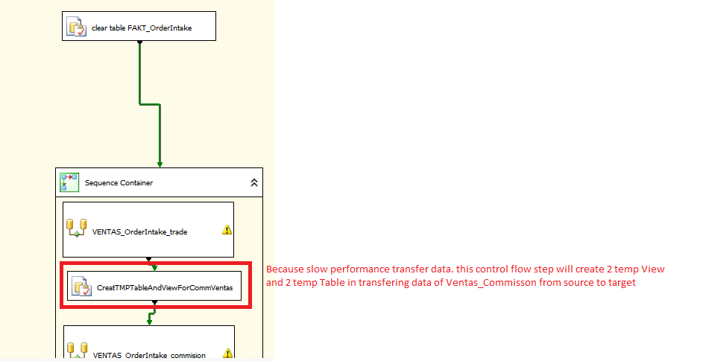

* 1. Source query loading change

**Old source load** **new source load**

 

1. Test Process
   1. Fakt_OrderComplete and Fakt_OrderCompleteDB2

Local test environment

**Step 1 :**

Clone all structure staging database to Staging_Model Database by using SQL compare

**Step 2:**

Deploy changes structure to Staging_Model

**Step 3:**

Restore database staging as new database with new name StagingTest

**Step 4:** Deploy new structure from Staging_Model to StagingTest

**Step 5:** Run SSIS package Fact_OrderComplete with connecting to StagingTest

**Step 6** :Test Case compare data of StagingTest with Staging



* 1. Fakt_OrderIntake

Local test environment

**Step 1 :**

Clone all structure staging database to Staging_Model Database by using SQL compare

**Step 2:**

Deploy changes structure to Staging_Model

**Step 3:**

Restore database staging as new database with new name StagingTest

**Step 4:** Deploy new structure from Staging_Model to StagingTest

**Step 5:** Run SSIS package Fact_OrderComplete with connecting to StagingTest

**Step 6 :**Test Case compare data of StagingTest with Staging



* 1. Board